**ЗАДАНИЕ**

**Попробуйте распределить культовые здания, предметы и символы в соответствии с религиями.**

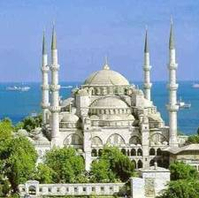 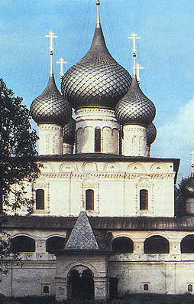 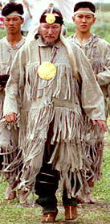 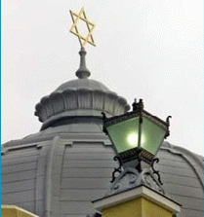 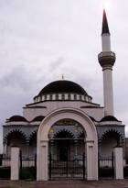

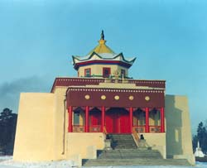 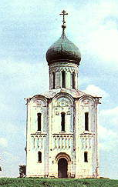 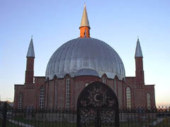 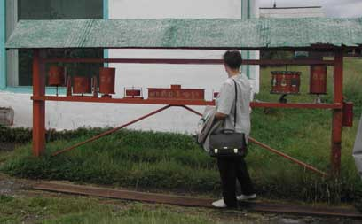

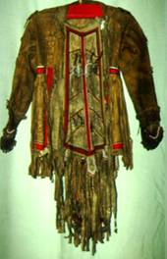 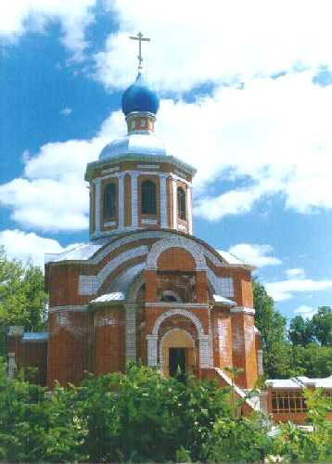 J0301044 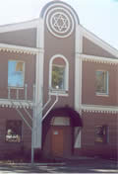 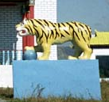 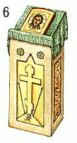

\

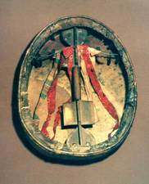 J0301052 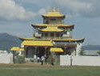 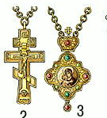 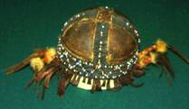 SY01462_

|  |  |  |  |  |
| --- | --- | --- | --- | --- |
| **Православие** | | | | |
|  |  |  |  |  |

|  |  |  |  |  |
| --- | --- | --- | --- | --- |
| **Мусульманство** | | | | |
|  |  |  |  |  |

|  |  |  |  |  |
| --- | --- | --- | --- | --- |
| **Буддизм** | | | | |
|  |  |  |  |  |

|  |  |  |  |  |
| --- | --- | --- | --- | --- |
| **Иудаизм** | | | | |
|  |  |  |  |  |

|  |  |  |  |  |
| --- | --- | --- | --- | --- |
| **Традиционные верования (шаманство)** | | | | |
|  |  |  |  |  |